14.51: a)
b) The gauge pressure at a depth of 15.0 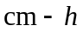below the top of the mercury column must be that found in part (a); 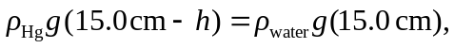 which is solved for 